Write a C++ Program to implement the following Flow Chart.
declare int a
a < 5 ?
cin >> a
cout << ″Enter a″
a < 10 ?
a < 15 ?
a < 20 ?
cout << ″a < 5″
cout << ″5 <= a < 10″
cout << ″10 <= a < 15″
cout << ″15 <= a < 20″
end
Y
Y
Y
Y
N
N
N
N

Input
// ECE 2305 - Tutorial 12
#include <iostream>
using namespace std;

int main() {
int num;
cout << "Please enter a value: ";
cin >> num;
if (num < 5) {
cout << "The number is less than 5." << endl;
}
else if (num < 10) {
cout << "5 <= number < 10" << endl;
}
else if (num < 15) {
cout << "10 <= number < 15" << endl;
}
else if (num < 20) {
cout << "15 <= number < 20" << endl;
}

system("pause");
return 0;
}
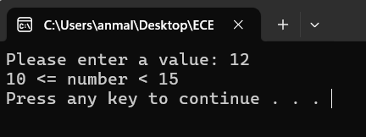
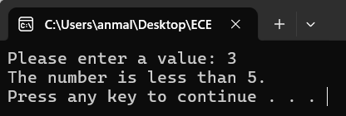
Output
